**Q.1.** **Write an assembly language program to print hello world using mov ah,02 service**

**routine.**

**dosseg**

**.model small**

**.stack 100h**

**.data**

**.code**

**main proc**

**mov dl,'h'**

**mov ah,2**

**int 21h**

**mov dl,'e'**

**mov ah,2**

**int 21h**

**mov dl,'l'**

**mov ah,2**

**int 21h**

**mov dl,'l'**

**mov ah,2**

**int 21h**

**mov dl,'o'**

**mov ah,2**

**int 21h**

**mov dl,'w'**

**mov ah,2**

**int 21h**

**mov dl,'o'**

**mov ah,2**

**int 21h**

**mov dl,'r'**

**mov ah,2**

**int 21h**

**mov dl,'l'**

**mov ah,2**

**int 21h**

**mov dl,'d'**

**mov ah,2**

**int 21h**

**mov ah,4ch**

**int 21h**

**main endp**

**end main**

**Q.2.** **Write Assembly program to Input Character from user and display it.**

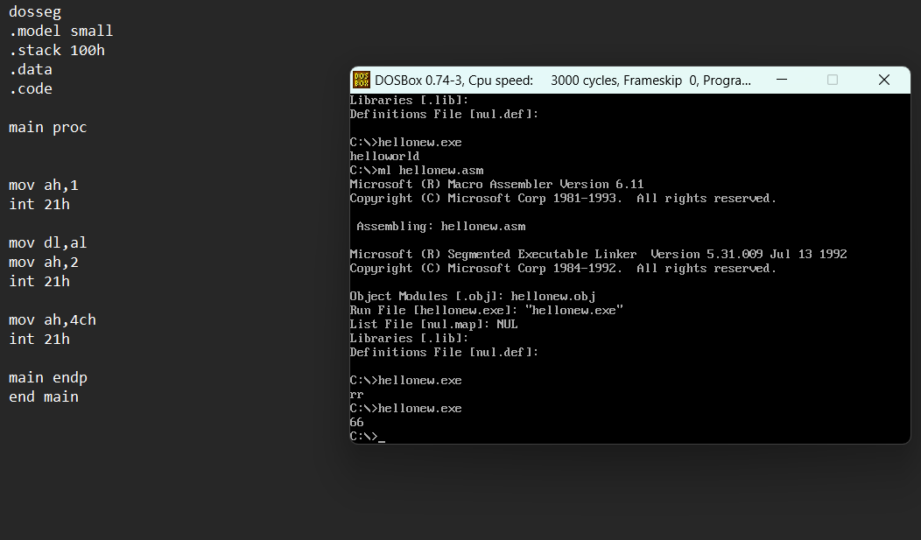

**Q.3.** **Take number and print the next number**

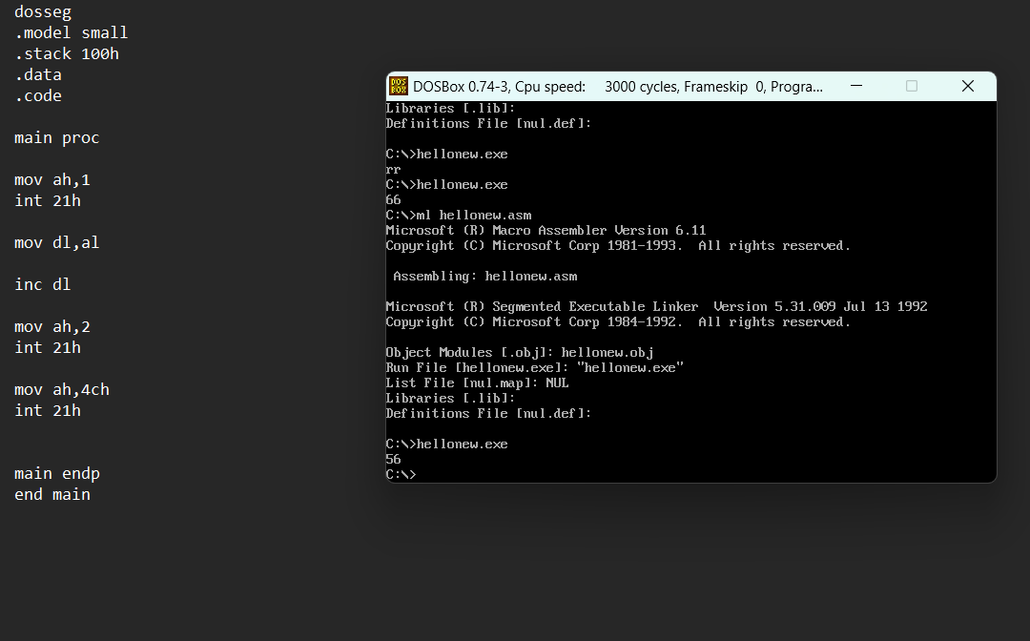

**Q.4.** **Take a number and print the previous number.**

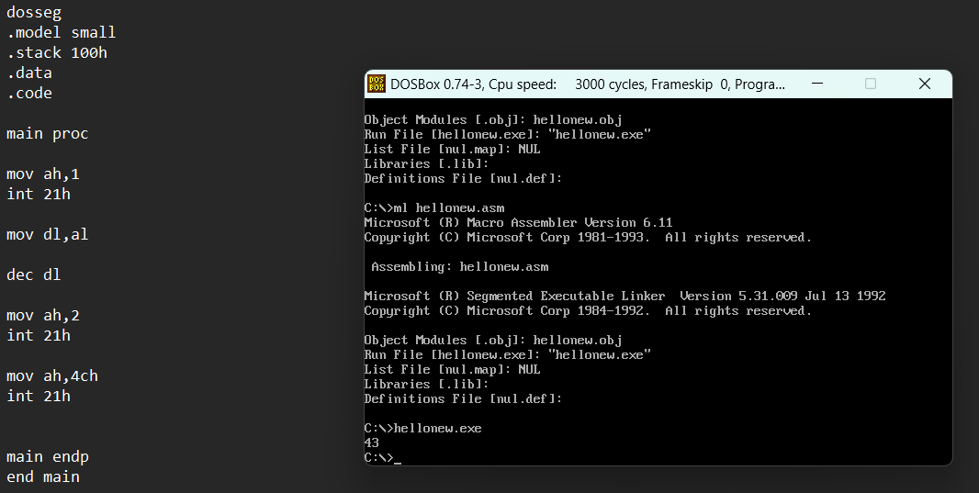

**Q.5.Write Assembly program to Input Lower Case letter from user and display it’s**

**upper case. (Subtract 32 in ASCII)**

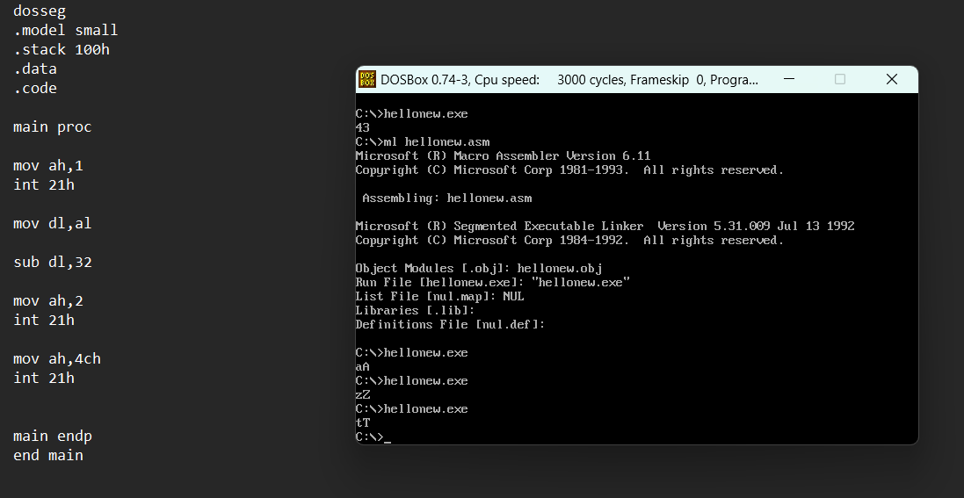

**Q.6.** **Write Assembly program to Input Upper Case letter from user and display it’s**

**lower case. (ADD 32 from ASCII)**

**Q.7.** **Write Assembly program to input letter from the user and display the next**

**character**

**Q.8.** **Write an assembly language program to ADD two values.**

**Q.9.** **Write an assembly language program to subtract two values.**